**Site Resources Standards**

**--Site Resources website:** <https://site-resources.aauw.org>

**--Colors:**

Blue R45 G66 B 125 #2d427d

Light blue #E6F0FB interior of textboxes

Eggplant R92 G 41 B70 #5c2946

Green R92 G135 B39 #5c8727

Other colors that could be used later.

Dark Peach R252 G183 B112 #fcb770

Light Peach R252 G209 B165 #fcd1a5

Text is a dark grey not black – making it black adds some emphasize.

Main Headings Blue

Sub Headings Eggplant

Dates and emphasis Green

Textboxes outline in Blue and filled with light blue

Links all come out as red

**Standard color codes** <https://www.computerhope.com/htmcolor.htm>

- -Code to **add textbox parts** in bold are placed before and after text you want in the box.

**<p style="padding: 2px 6px 4px 6px; color: #555555; background-color: #e6f0fb; border: #2d427d 3px solid;">**Since AAUW’s founding our members and supporters have spoken out about policies important to women and girls. Without their voices, invaluable legislation would have never been passed. In recent years, such legislation included the Family and Medical Leave Act, the Matthew Shepard and James Byrd Jr. Hate Crimes Prevention Act, and the Lilly Ledbetter Fair Pay Act.**</p>**

**Content in the textbox** should have a color change to black (not bold) – it is a little clearer.

**--Contact at Site Resources**: Cheryl Bond-Nelms, [bonc@aauw.org](mailto:bonc@aauw.org)

**ONE space between sentences.**

**PAYPAL**

It says this is a shareable link

<https://www.paypal.com/donate?hosted_button_id=JDAJG6VXG7QYG>

|  |  |
| --- | --- |
| [https://ci5.googleusercontent.com/proxy/1h6hQTNYEGN9EiFCTU3G2eRj_G9oJaFB7RhkotioS6OhUSbUqaSTr8MX7YELy8tbtZ9DLMcmHWA_pSAiZnmnvfRMTDMaRb86O4k=s0-d-e1-ft#https://www.paypalobjects.com/ppcp/images/donations.jpg](https://www.paypal.com/donate?hosted_button_id=JDAJG6VXG7QYG) | [Donate to Poughkeepsie Branch AAUW](https://www.paypal.com/donate?hosted_button_id=JDAJG6VXG7QYG)  Help support Poughkeepsie Branch AAUW by donating or sharing with your friends.  [www.paypal.com](http://www.paypal.com) |

**All documents** uploaded should be PDF no Word documents

**All links** (except other pages of the website – internal- should open in their own window.

**Code for table with 4 columns, 9 rows**

<table style="height: 114px;" width="578">

<tbody>

<tr>

<td></td>

<td></td>

<td></td>

</tr>

<tr>

<td></td>

<td>></td>

<td></td>

<td></td>

</tr>

<tr>

<td></td>

<td></td>

<td></td>

<td></td>

</tr>

<tr>

<td></td>

<td></td>

<td></td>

<td></td>

</tr>

<tr>

<td></td>

<td></td>

<td></td>

<td></td>

</tr>

<tr>

<td></td>

<td></td>

<td></td>

<td></td>

</tr>

<tr>

<td></td>

<td></td>

<td></td>

<td></td>

</tr>

<tr>

<td></td>

<td></td>

<td></td>

<td></td>

</tr>

<tr>

<td></td>

<td></td>

<td></td>

<td></td>

</tr>

</tbody>

</table>

**Code for table with 2 columns, 9 rows**

<table style="height: 114px;" width="578">

<tbody>

<tr>

<td></td>

<td></td>

</tr>

<tr>

<td></td>

<td>></td>

</tr>

<tr>

<td></td>

<td></td>

</tr>

<tr>

<td></td>

<td></td>

</tr>

<tr>

<td></td>

<td></td>

</tr>

<tr>

<td></td>

<td></td>

</tr>

<tr>

<td></td>

<td></td>

</tr>

<tr>

<td></td>

<td></td>

</tr>

<tr>

<td></td>

<td></td>

</tr>

</tbody>

</table>

**Code for table with 2 columns, 2 rows**

<table style="height: 114px;" width="578">

<tbody>

<tr>

<td></td>

<td></td>

</tr>

</tbody>

</table>

**DO NOT TOUCH THE PAGE WITH THE CALENDAR**. Update the calendar though the Google site by clicking on the +Google Calendar box on the bottom right and sign in with the [editor.aauw.poughkeepsie@gmail.com](mailto:editor.aauw.poughkeepsie@gmail.com) account.

**Widget for adding links to homepage** is “Text.” One can change the order just as you do menu items.

**Border for pictures** - can only done in Gallery---- **You get borders around pictures by using a gallery. When editing the page click ‘Add Media’ and then ‘Create Gallery.’ The Gallery will put frames around the images. It also makes the images very stable. You select 1, 2 or 3 columns – 3 would make very small pictures.**

**If you have an odd picture it will be in a column and you cannot center it. What I have done is put the array in a gallery and then just add in the odd picture in the usual way (not in a gallery).**

**I think to make a space between paragraph** when you are in a textbox, the following will work: Choose the ‘Text’ option from the ‘Visual/Text’ on the page and enter this code **</span>** at the beginning of the line where you want the space. It seems it needs to be on a line by itself.

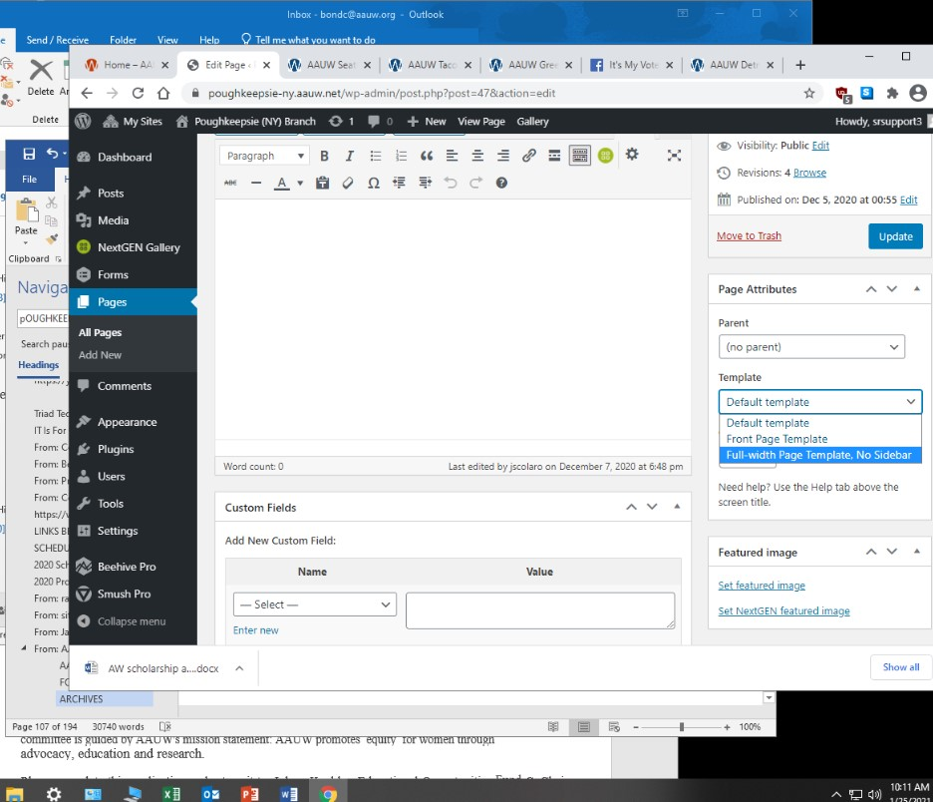

And if you want to remove the sidebar on a page, select no sidebar in Page Attributes.

Image left.

**Emails**

Be sure there is [**mailto:(email**](mailto:(email) **addresss)** for email addresses and not https: or such.

**Adding a link to a graphic image**

Insert the image to the page. Copy the link for the document that you want to link from this image.

Select the image, click on the edit function, delete the link for the picture and put in the link for the document – be sure to **apply. Also Update as always**